Removing Cookies from Firefox 3.x

- From any tab in the Firefox browser, select Tools | Options menu item.

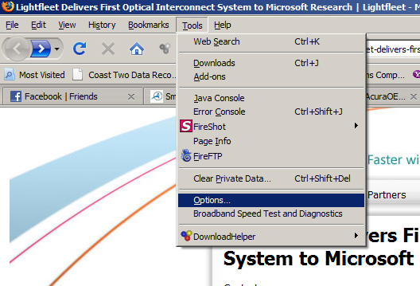

- From the popup window, select the Show Cookies button found in the Cookies section.

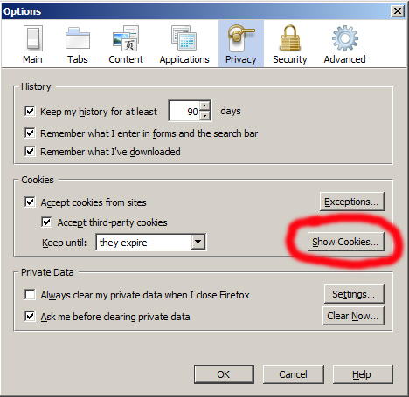

- Enter UCAIug in the Search text box found in the Cookie dialog box that will display. DO NOT press the <ENTER> key!!!

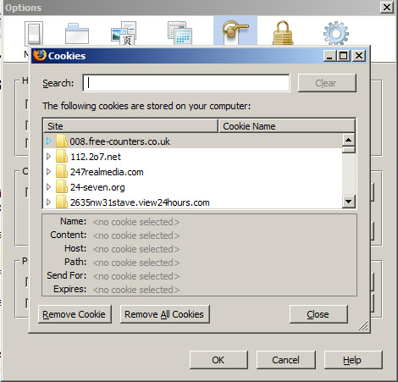

- Firefox will display all cookies that match the text entered in the Search box. You can Control-select or Shift-select as many cookies as you wish to delete by clicking your left-mouse button while either holding the Control or Shift keys.

- Once you have selected the cookies you wish to delete, select the Remove Cookie button. Firefox will delete the selected cookies.

- Close out of all the dialog boxes until you are returned to the main Firefox browser window.

- Close the Firefox browser.

- Restart the Firefox browser and navigate to a UCAIug site (UCAIug.org, CIMug.org, OSGug,org, etc).

- Attempt to login by entering your account credentials. You should successfully login.

